**ABSTRACT**

The loan approval process is a critical decision for financial institutions, directly influencing their profitability and risk management. Traditionally, this process relies on a manual evaluation of an applicant's financial history, which can be time-consuming and prone to human error. This paper presents a machine learning-based approach for automating and enhancing the accuracy of loan approval predictions.

The proposed system leverages historical data of loan applicants, including demographic details, income, credit score, and employment history, to train predictive models. Several machine learning algorithms, such as Logistic Regression, Decision Trees, Random Forests, and Support Vector Machines (SVM), are implemented and compared to determine the most effective model for predicting whether a loan application should be approved or rejected.

The model is trained on a dataset of past loan applications and is evaluated based on performance metrics such as accuracy, precision, recall, and F1-score. The integration of machine learning techniques not only accelerates the approval process but also reduces biases, improving fairness and consistency in decision-making.

The results demonstrate that machine learning can significantly improve the prediction accuracy of loan approval outcomes, enabling financial institutions to streamline operations while minimizing risk. This automated approach provides a scalable, data-driven solution for loan management, enhancing customer experience and operational efficiency.

**CHAPTER 1**

**INTRODUCTION**

* 1. **Overview**

Loan Prediction is very helpful for employee of banks as well as for the applicant also. The aim of this Paper is to provide quick, immediate and easy way to choose the deserving applicants. Dream housing Finance Company deals in all loans. They have presence across all urban, semi urban and rural areas. Customer first applies for loan after that company or bank validates the customer eligibility for loan. Company or bank wants to automate the loan eligibility process (real time) based on customer details provided while filling application form. These details are Gender, Marital Status, Education, Number of Dependents, Income, Loan Amount, Credit History and other. This project has taken the data of previous customers of various banks to whom on a set of parameters loan were approved. So the machine learning model is trained on that record to get accurate results. Our main objective of this project is to predict the safety of loan. To predict loan safety, the KNN, SVM and Naïve bayes algorithm are used. First the data is cleaned so as to avoid the missing values in the data set.



Figure 1.1: Loan Approval

Loan Distribution is the main business part of many banks. The main portion of banks income comes from the loan distributed to customers. These banks apply interest on loan which are distributed to customers. The main objective of banks is to invest their assets in safe customers. Up to now many banks are processing loans after regress process of verification and validation. But till now no bank can give surety that the customer who is chosen for loan application is safe or not. So to avoid this situation we introduced a system for the approval of bank loans known as Loan Prediction System Using Python. Loan Prediction System is a software which checks the eligibility of a particular customer who is capable of paying loan or not. This system checks various parameters such as customer’s martial status, income, expenditure and various factors. This process is applied for many customers of trained data set. By considering these factors a required model is built. This model is applied on the test data set for getting required output. The output generated will be in the form of yes or no. yes indicates that a particular customer is capable of paying loan and no indicates that the particular customer is not capable of paying loan. Based on these factors we can approve loans for customers. It’s a common problem in the financial industries and one of the major risks of offering loans. Of course, default does not happen the majority of the time and the lending banks usually able to make up the loss from a defaulting loan from other fully paid loans and their accompanied interests. Furthermore, banks issuing loans with higher interest rate to individuals with high probability of default - the financial institutions are trading off an increased chance of default with an increased profit from the high interest. All things considered, default is a fact of life and most financial institutions have a well-established practice to minimize its impact and absorbing the loss. But what about a situation where instead of a single bank is issuing the loan, the loan is comprised of funds from several investors? Lending Club is one of the many peer-to-peer lending company that gives rise to this peculiar situation. In plain words, peer-to-peer lending company acts as a broker between borrowers and investors.

The company creates a platform where borrowers can create small unsecured personal loans, and investors can seek out these loans and decide which loans to invest from. Borrowers obtain the loan they want, investors get to profit from the loan interest, and the company gets a cut from both parties (origination fee from borrowers and service fee from investors). This also means that when a loan goes default, it’s no longer a single bank that is absorbing the loss - single or multiple individual investors will be absorbing it instead. The overall profit might be positive if all the loans were originated from a single lender as other fully paid loans could cover the loss, but this is no longer the case as there will be winners and losers among this new form of lending practices if the investors did not diversify. An obvious solution to this problem is to predict whether a particular loan will go default based on initial information provided by the borrowers and their credit report. There’s no doubt Lending Club already has an existing model in place to approve loans posted on their website. This paper will explore the process and result on formulating a new machine learning model that could predict a loan default; but more importantly, the model will focus on

**1.2 Loan approval prediction is used for several reasons:**

* **Risk assessment:** Lenders use loan approval prediction models to assess the risk associated with lending money to individuals or businesses. By analyzing various factors such as credit history, income, employment status, and other relevant data, lenders can estimate the probability of a borrower defaulting on the loan. This helps them make informed decisions about whether to approve a loan application or not.
* **Efficiency and speed:** Loan approval prediction models automate and streamline the loan application process, making it faster and more efficient. Instead of manually reviewing each application, lenders can use predictive models to quickly assess the likelihood of approval. This saves time for both the lenders and the borrowers, enabling faster access to funds for those who qualify.
* **Improved decision-making:** Loan approval prediction models provide lenders with objective data-driven insights to make more accurate decisions. By considering various factors and historical loan performance data, lenders can better understand the creditworthiness of applicants and make more informed judgments. This reduces the chances of approving loans to high-risk borrowers and helps mitigate potential financial losses.
* **Fairness and transparency:** Predictive models can help ensure fairness and transparency in the loan approval process. By relying on data and predefined algorithms, loan decisions can be made based on objective criteria rather than subjective judgment. This reduces the potential for bias and discrimination, ensuring that loan approvals are based on consistent and unbiased evaluation.
* **Risk management and fraud detection:** Loan approval prediction models assist in identifying potential instances of fraud or misrepresentation. By analyzing patterns and anomalies in loan applications, lenders can flag suspicious activities and investigate further before approving a loan. This helps mitigate the risk of fraudulent borrowers and minimizes financial losses due to default or non-repayment.

**1.3 Advantages of loan approval**

* **Access to funds:** Loan approval provides borrowers with access to much-needed funds for various purposes such as starting a business, purchasing a home, or covering unexpected expenses. Loans can help individuals and businesses achieve their goals and full fill their financial needs when they don't have immediate access to sufficient funds.
* **Financial stability:** Approved loans can contribute to financial stability for borrowers. By providing access to funds, loans can help individuals manage cash flow, meet their financial obligations, and bridge temporary gaps in income. This can prevent financial distress and improve overall financial well-being.
* **Building credit history:** Successfully repaying a loan can help borrowers establish or improve their credit history. Timely loan repayments demonstrate responsible financial behaviour and can positively impact credit scores. This, in turn, can open doors to better loan terms and opportunities for future borrowing.
* **Investment opportunities:** Loan approval enables borrowers to invest in opportunities that can yield long-term benefits. For example, entrepreneurs can secure ` financing to start or expand their businesses, which can lead to job creation, economic growth, and increased income. Similarly, individuals can use loans to invest in education, real estate, or other assets that have the potential to generate returns.
* **Flexibility and customization:** Loans come in various forms, such as personal loans, mortgages, business loans, or student loans. This provides borrowers with the flexibility to choose the type of loan that best suits their needs and preferences. Lenders also offer different repayment terms, interest rates, and loan amounts, allowing borrowers to customize the loan according to their specific requirements.

**1.4 Disadvantages of loan approval**

* **Debt and interest payments:** Taking out a loan means taking on debt that needs to be repaid with interest. The repayment of the loan, along with the accrued interest, adds to the borrower's financial obligations and can put a strain on their monthly budget. Borrowers need to consider whether they can comfortably manage the repayment terms and factor in the interest costs over the loan's duration.
* **Financial burden and stress:** Loans can become a significant financial burden, especially if the borrower's income or financial situation changes unexpectedly. The monthly loan repayments can put pressure on the borrower's budget, potentially leading to financial stress and impacting their overall quality of life.
* **Risk of default and credit damage:** If a borrower fails to make loan payments as agreed, it can result in default. Defaulting on a loan can have serious consequences, such as damage to the borrower's credit score, additional fees and penalties, and potential legal action by the lender. It can also make it more challenging to obtain future loans or credit.
* **Overborrowing and overextension:** Loan approval may tempt borrowers to take on more debt than they can reasonably handle. Overborrowing can lead to overextension, where borrowers have difficulty meeting their monthly loan payments along with other financial obligations. This can create a cycle of debt and financial instability.
* **Impact on long-term financial goals:** Loans, particularly those with long repayment terms, can affect a borrower's ability to pursue other financial goals. The monthly loan payments can limit the amount of disposable income available for savings, investments, or other financial aspirations, potentially delaying progress towards long-term objectives.
  1. **Aim and Objective**

The aim of the project is loan approval prediction using machine learning is to develop predictive models that can accurately assess the creditworthiness of loan applicants and predict the likelihood of loan approval.

**Objectives of Project**

The objective of loan approval prediction is :

* Data Collection
* Data Pre-processing & Feature Extraction
* Data Analysis
* Building Machine Learning Models : SVM, LR, KNN & NB
* Model Evaluation
* Web application to demonstrate the result/prediction (approved or Not)

**The primary objectives of loan approval prediction using machine learning techniques include:**

**Predicting loan approval outcome:** The main objective is to accurately predict whether a loan application will be approved or rejected. Machine learning models aim to analyze various features and patterns in historical loan data to make predictions about the approval status of new loan applications. This helps lenders make informed decisions and manage their loan portfolios effectively.

**Assessing creditworthiness:** Machine learning models aim to assess the creditworthiness of loan applicants by analysing their financial and personal information. The objective is to determine the risk associated with lending to a particular applicant. By considering factors such as credit history, income, employment status, debt-to-income ratio, and other relevant variables, the models aim to provide an accurate assessment of an applicant's ability to repay the loan.

**Identifying high-risk applicants**: Another objective is to identify applicants who are likely to default on their loans or have a higher risk of non-repayment. Machine learning models aim to analyse patterns and historical data to identify indicators of higher risk. This helps lenders prioritize their resources and focus on applications that have a higher likelihood of approval and lower risk of default.

**Enhancing efficiency and accuracy:** The objective is to improve the efficiency and accuracy of the loan approval process. Machine learning models can analyse a vast amount of data and identify complex relationships and patterns that may not be easily detected by human reviewers. The models aim to provide accurate predictions and reduce errors in loan decision-making, leading to a more efficient and reliable loan approval process.

**1.6 Scope:** The scope of loan approval prediction involves the application of machine learning techniques and models to assess the creditworthiness of loan applicants and predict the likelihood of loan approval. It aims to provide lenders with more accurate and efficient loan approval decisions, ultimately improving the loan application process and risk management.

**CHAPTER 2**

**SYSTEM REQUIREMENT SPECIFICATIONS**

**2.2 System Requirement Specifications**

Prerequisites exam is simple for undertaking improvement. Prerequisites need to be archived, vast, quantifiable, and testable and characterised to some extent of detail adequate for framework plan. Necessities can be engineering, underlying, social, realistic, and beneficial. A Software Requirements Specification (SRS), product requirements specific in attaining the depiction planned reason and the weather for programming being worked on.

**2.2.1 Functional Requirements**

The tools to execute the Python programs can be many, among that we can go with Visual Studio, Anaconda Navigator (Jupyter Notebook) or any IDLE based on Python. The online tool from Google can be an effective solution towards the execution of Python coding.

* **Approach 1: Jupyter Notebook (Anaconda Navigator)**

This tool is also known as IPython Notebook, and it is Open-Source Distribution Software and provides the platform for development of web applications, computational interactive and specific environment for the users to create notebook documentations. It support for individual code execution, browser based interoperability, can plot various graphs using python libraries and also support for many open source libraries like Bootstrap, JQuery, Tornado, Matplotlib , Seaborn and others.

The features of Jupyter Notebook can be listed as:

* Flexible Notebook Interface
* Useful tool in Machine learning, Deep learning and Ai based Application and model Design.
* Creating and sharing the computational Documents.

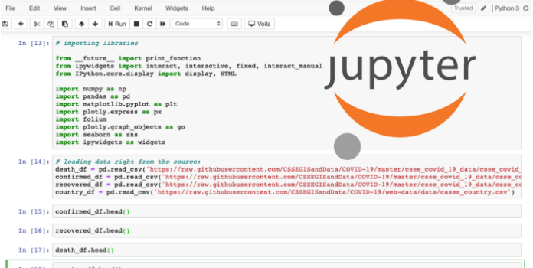

Figure 2.2: Jupyter Notebook Dashboards 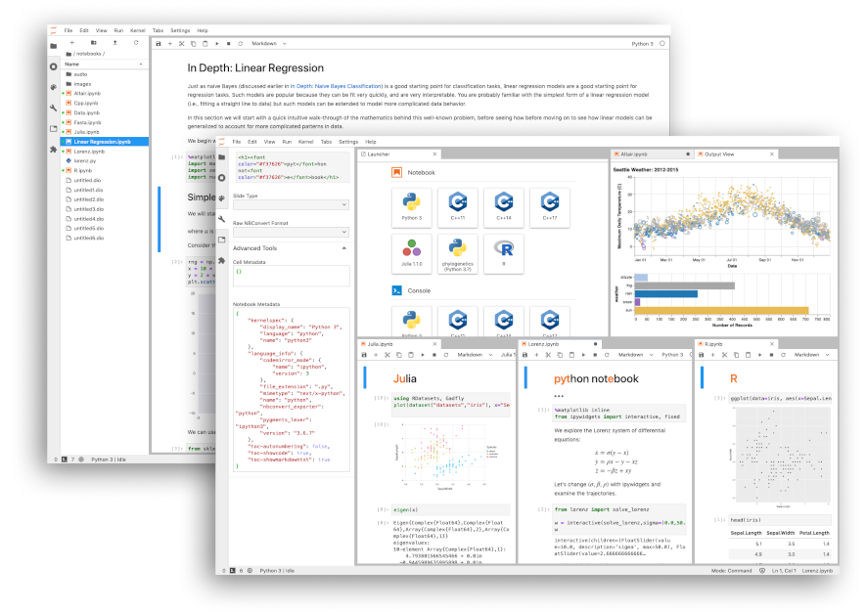

Figure 2.3: Notebook support for plotting

* **Approach 2: Python IDLE**

**Python IDLE (Python Integrated Development and Learning Environment) help is writing the code very effectively and efficiently and helpful tool to the Python learning who wants to start from the scratch and beginners can have an advantage to execute the code easily. This is a powerful interpreter and compiler to run the code.**

**It’s an Interactive Interpreter also known as shell, which executes the python written code, reads the input, evaluate the statements and print the output on the standard output screen provided.**

**File Editor Help to edit the code, save the program in text files and store as .py file.**

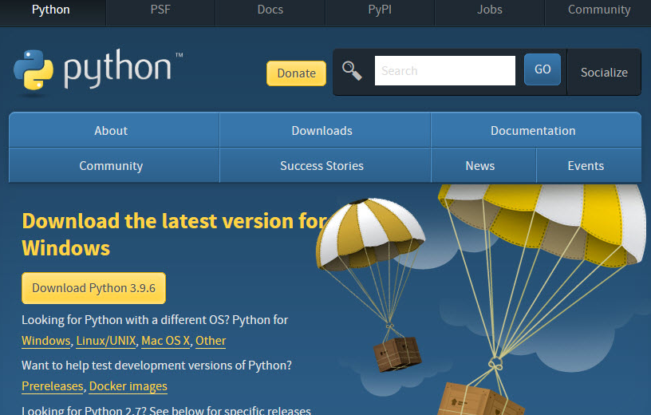

**Figure 2.4: Python IDLE Download Page**

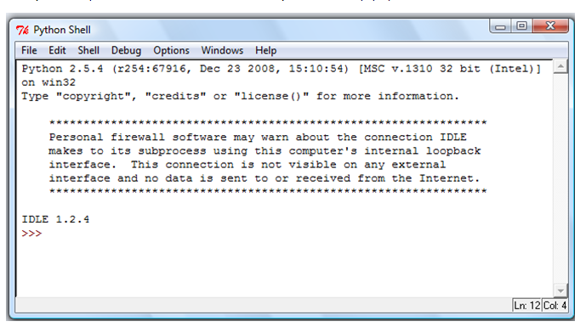

**Figure 2.5: Python IDLE prompt to write and execute code**

* **Approach 3: Google Colab**

**Google Colab, also called as Colab in short is a powerful Machine Learning, Deep Learning and Data Analysis Tool that allows mixing the Python script along with text document. Rich support for Plotting the graphs, Diagram, Charts, Import Images, HTML Tags Support and LATEX format API conversions. Additional functional is it works on cloud model where document can be accessed and run on any platform independent of framework design and operating system. The runtime support for Virtual Hard Disk space and 12GB of RAM to execute the application is very excited feature of Colab. The uploading of files is very easy in this application so that it connects to the runtime.**

**Some of the important feature is:**

* **Remote Desktop Connection**
* **Runtime Environment**
* **Dataset Upload Features**
* **I/O operations and Operating System API Support**
* **General Processing Unit (GPU) availability**

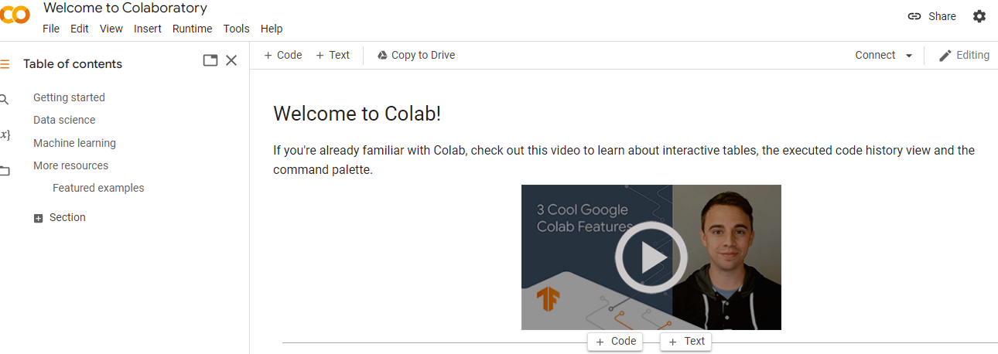

Figure 2.6: Welcome page of Google Colab

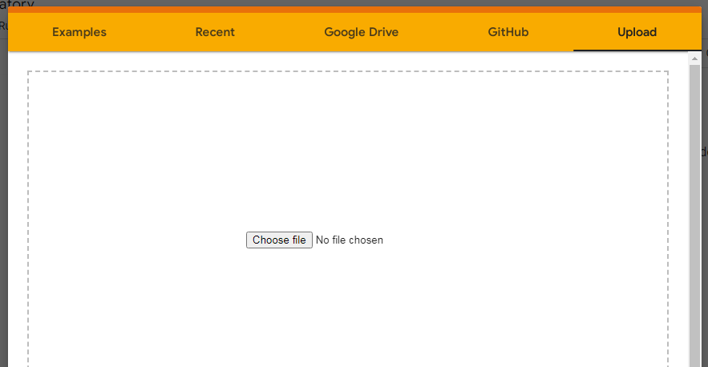

Figure 2.7: Upload the Notebook File

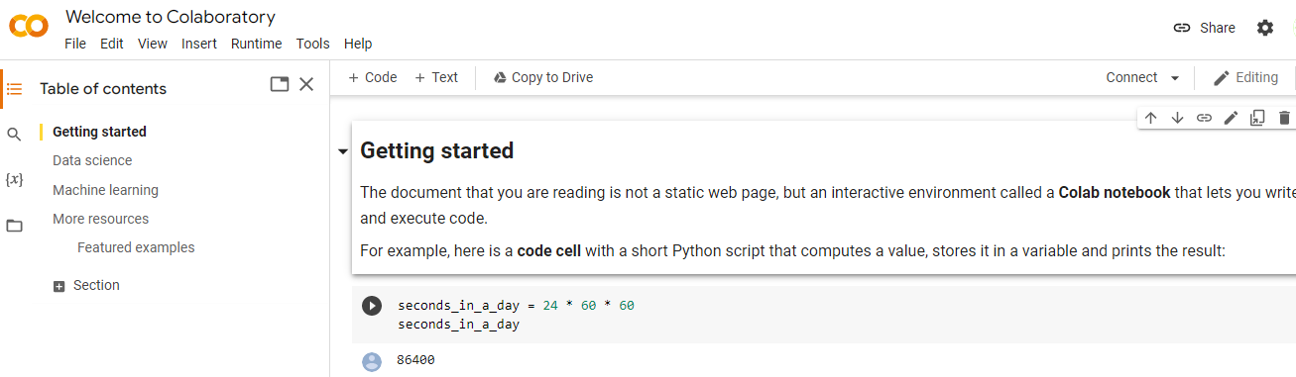

Figure 2.8: Start the Application Page

Requirements analysis is critical for project development. Requirements must be documented, actionable, measurable, testable and defined to a level of detail sufficient for system design. Requirements can be architectural, structural, behavioural, functional, and functional.

A software requirements specification (SRS) is a comprehensive description of the intended purpose and the environment for software under development.

**2.2.2 Non-Functional Requirements**

**Software Requirements**

Scripting language : Python Programming

Scripting Tool : Anaconda Navigator (Jupyter Notebook) or Google Colab

Operating System : Microsoft Windows 8/ 10 or 11

Dataset : Loan Approval Dataset

Python Packages : NumPy, Pandas, Matplotlib , Seaborn Packages etc..

**Hardware Requirements**

Processor : 3.0 GHz and Above

Output Devices : Monitor (LCD)

Input Devices : Keyboard

Hard Disk : 1 TB

RAM : 8GB or Above

**2.2.3 Dataset:**

When it comes to loan approval prediction, require loan datasets. These datasets typically contain information about loan applicants and their loan approval outcomes. It's important to ensure that the dataset used is relevant to the specific loan approval prediction task and adheres to privacy and legal considerations. Additionally, it's common to perform data pre-processing and feature engineering steps on the dataset to prepare it for model training and evaluation.

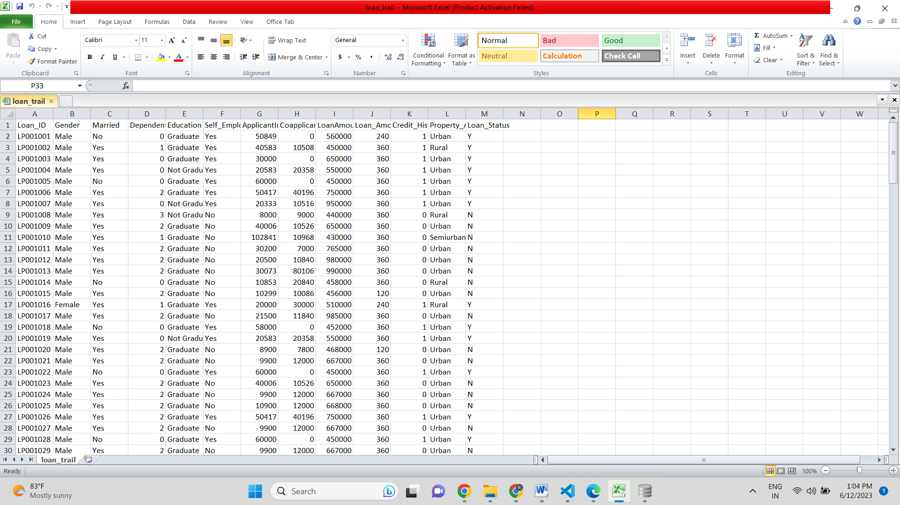

Figure 2.9: Loan Dataset

**CHAPTER 3**

**SYSTEM DESIGN**

A design specification is a written document that explains your product and specifies what you want it to perform as well as how the user should interact with it. While it may seem laborious to write everything down, it is the most crucial thing you can do in the early stages of product design and development. This is because the design specs direct the whole scope of your product development.

As the term suggests, a design specification is a document that outlines a project’s design needs. For the design team, this is a vital document since half of the success of a project depends on it. After extensive study, the document is created by the client and contains extremely comprehensive, specific design requirements that must be consistently applied until the project is completed. With such a list of requirements at hand, designers will be able to bring what the client sees to live.

**3.3.1 Existing System**

Till now loans are processed by various banks through pen and paperwork. When the large no of customers apply for bank loan these bank take lot of time to approve their loan. After approval of loan by the banks, there is no surety that the chosen applicant is capable of paying loan or not. Many banks use their own software’s for the loan approval. In existing system we use data mining algorithms for the loan approval; this is the old technique for the approval of loan. Mutiple data sets are combined and form a Generalised datasets, and different machine learning algorithms are applied to generate results. But these techniques are not up to the mark. Due to this huge banks are suffering from financial crises. To resolve this issue we introduce a new way for approval of loans.

**3.3.2 Proposed Methodology**

This system predict whether the loan is approve or reject. This System refers the following things or ways.

1. Data Collection
2. Analysis of Data
3. Model Selection
4. Data Visualisation
5. Prediction
6. Output

* **Data Collection:**

Data collection in loan approval involves gathering relevant information about loan applicants to assess their creditworthiness and make informed decisions regarding loan approval.

**Here are some key aspects of data collection in the context of loan approval:**

* Personal Information: Loan applications typically require applicants to provide personal details, such as name, address, contact information, date of birth, and social security number. This information helps identify and verify the identity of the applicant.

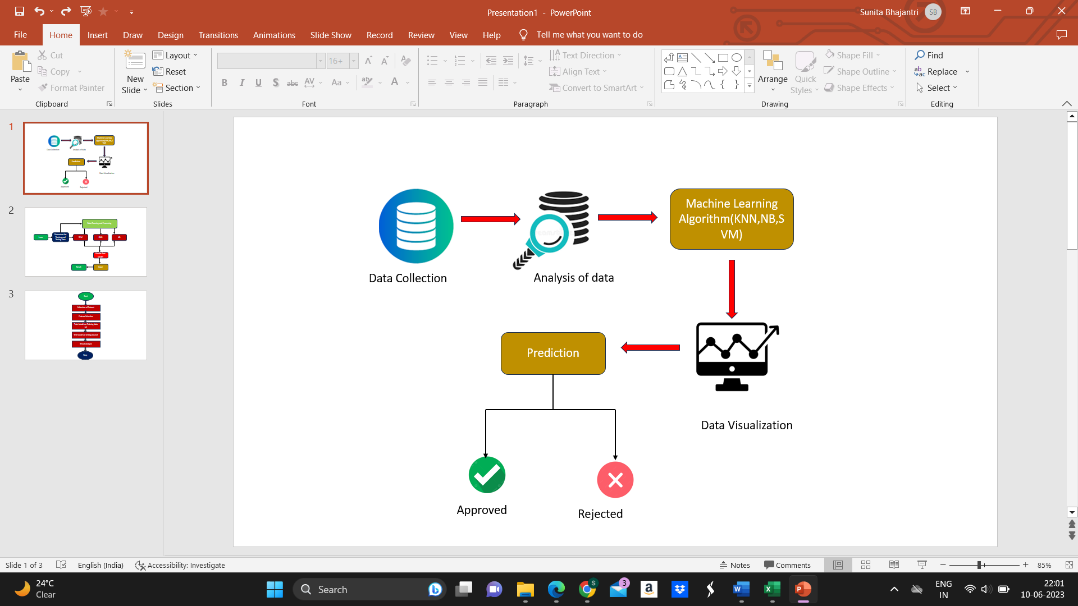

Figure 3.1: Proposed Diagram

* Financial Information: Lenders collect financial information from applicants to assess their ability to repay the loan. This includes details such as income, employment status, employer information, length of employment, and other sources of income. Financial statements, tax returns, and bank statements may also be requested to verify the applicant's financial stability.
* Credit History: Lenders obtain credit history information to evaluate an applicant's creditworthiness. This includes credit scores, credit reports, and payment history on previous loans, credit cards, and other forms of credit. Credit history helps assess the applicant's repayment behavior and the level of risk associated with lending to them.
* Loan Purpose and Amount: Applicants are typically required to specify the purpose of the loan and the desired loan amount. This information helps lenders understand the borrower's intentions and evaluate the feasibility of the loan.
* **Data Analysis:**

The analysis of data in loan approval prediction aims to uncover patterns, relationships, and insights that can inform loan approval decisions and improve the accuracy of predictive models. It helps lenders understand the factors that contribute to loan approval outcomes and assists in making informed decisions regarding loan applications and prediction involves examining and extracting insights from the collected data to understand patterns, relationships, and factors that contribute to loan approval decisions.

* **Model Selection:**

Model selection in loan approval prediction involves choosing the most appropriate machine learning algorithm or model that can effectively predict loan approval outcomes based on the available data. Ultimately, the selection of a model for loan approval prediction should be based on a comprehensive evaluation of factors such as problem complexity, data characteristics, interpretability requirements, performance metrics, and validation techniques. It's advisable to experiment with different models and techniques to find the optimal balance between performance, interpretability, and practical applicability within the loan approval context.

* **Data Visualization:**

Data visualization plays a crucial role in loan approval prediction in machine learning as it helps in understanding patterns, relationships, and trends in the data. Tools like Python's Matplotlib, Seaborn, Plotly, or Tableau can be utilized to create a variety of visualizations in loan approval prediction. It's important to choose the appropriate visualization techniques based on the data types, objectives, and the insights sought from the visualizations. Effective data visualization enhances understanding, facilitates communication, and supports decision-making in loan approval prediction.

* **Prediction:**

The prediction of loan approval involves using machine learning techniques to build models that can predict the likelihood of a loan being approved based on relevant features and historical data. It's important to note that the prediction of loan approval is a complex task influenced by various factors, and the accuracy of the predictions depends on the quality and relevance of the data, the choice of models, and the performance of the predictive algorithms. Regular evaluation and monitoring are necessary to maintain the effectiveness of the models in real-world scenarios.

**3.3.3 Architecture Diagram**

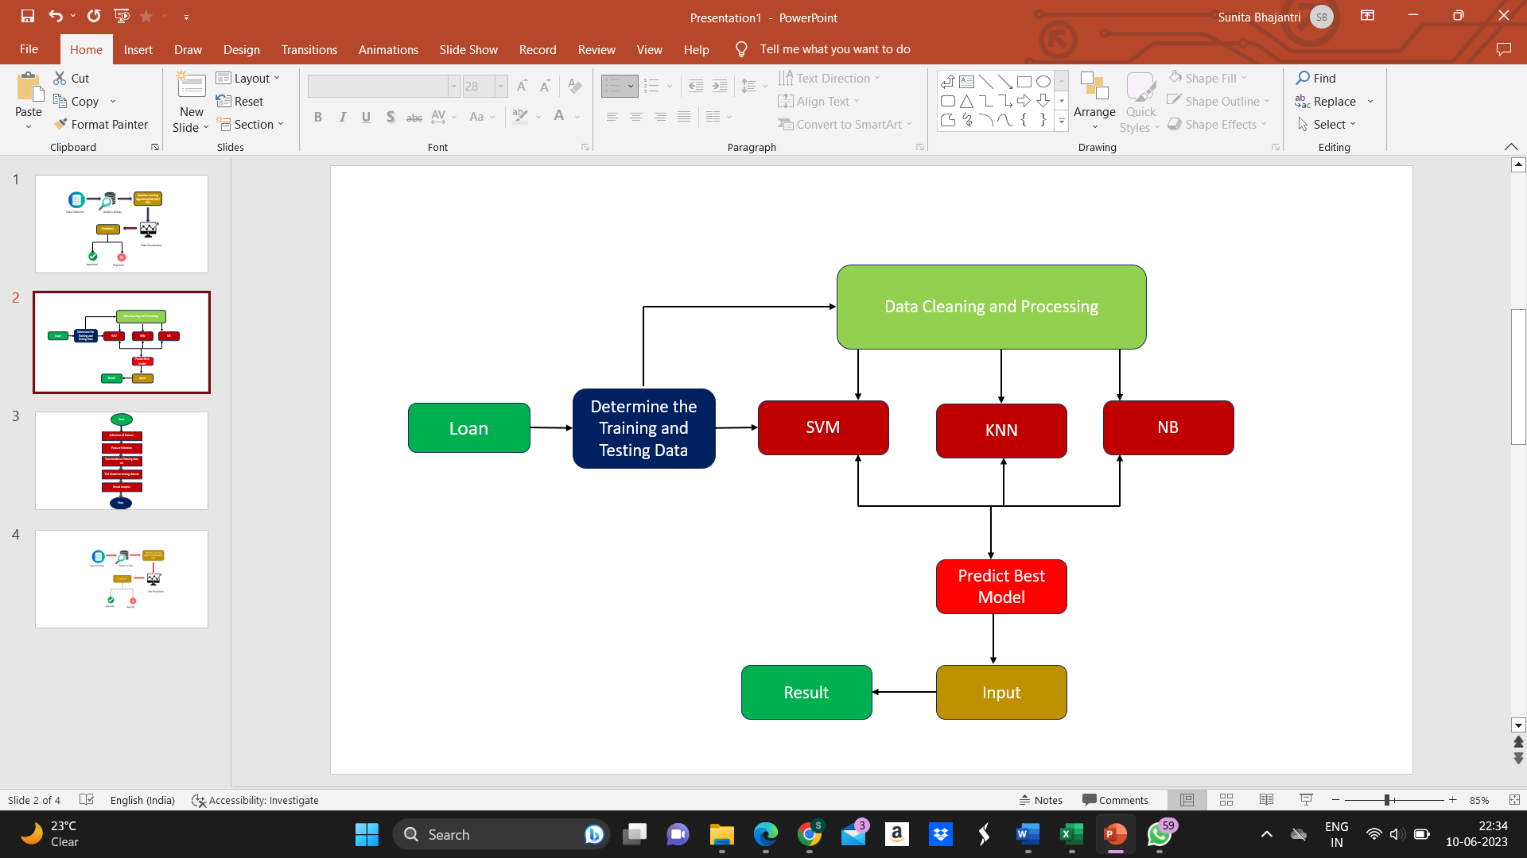

Figure 3.2: Architecture Diagram

* **Loan Dataset:** Loan Dataset is very useful in our system for prediction of more accurate result. Using the loan Data set the system will automatically predict which costumer’s loan it should approve and which to reject. System will accept loan application form as an input. Justified format of application form should be given as an input to get processed.
* **Determine the training and testing data:** Typically , Here the system separate a dataset into a training set and testing set ,most of the data use for training ,and a smaller portions of data is use for testing. after a system has been processed by using the training set, it makes the prediction against the test set.
* **Data cleaning and processing:** In Data cleaning the system detect and correct corrupt or inaccurate records from database and refers to identifying incomplete, incorrect, inaccurate or irrelevant parts of the data and then replacing , modifying or detecting the dirty or coarse data. In Data processing the system convert data from a given form to a much more usable and desired form i.e. make it more meaningful and informative
* **Models used:**

**1) SVM:** In this approach, each data item is plotted in a n-dimensional space, where n represents the number of features with each feature represented in a corresponding coordinates. A hyper plane is determined to distinguish the classes (possibly two) based on their features.

**2) Naïve Bayes (NB) Model:** The basis for NB model is Bayes Theorem (BT), where events are mutually exclusive similar to rolling a die. Moreover, the BT presumes that the input features also referred as predictors are independent in nature. Similarly, NB also presumes that the input features are independent in nature. But, this is impossible in the realistic procedures. Since this assumption leads to naïve, this algorithm is termed as Naïve Bayes algorithm. Thus, NB is a probabilistic algorithm, where the conditional probability is determined regarding the input features. On the other hand, during the dependent input features scenario, conditional probability is calculated twice resulting in improper results. Hence, for better prediction results with respect to NB model, independent input features are selected and processed

**CHAPTER 4**

**SYSTEM IMPLEMENTATION**

**4.1 System Implementation**

The purpose of System Implementation can be summarized as follows: making the new system available to a prepared set of users (the deployment), and positioning on-going support and maintenance of the system within the Performing Organization (the transition).

**Systems implementation** **is the process of:**

1. Defining how the information system should be built (i.e., physical system design),
2. Ensuring that the information system is operational and used,
3. Ensuring that the information system meets quality standard (i.e., quality assurance).

**Backend Code:**

* **Importing Packages**

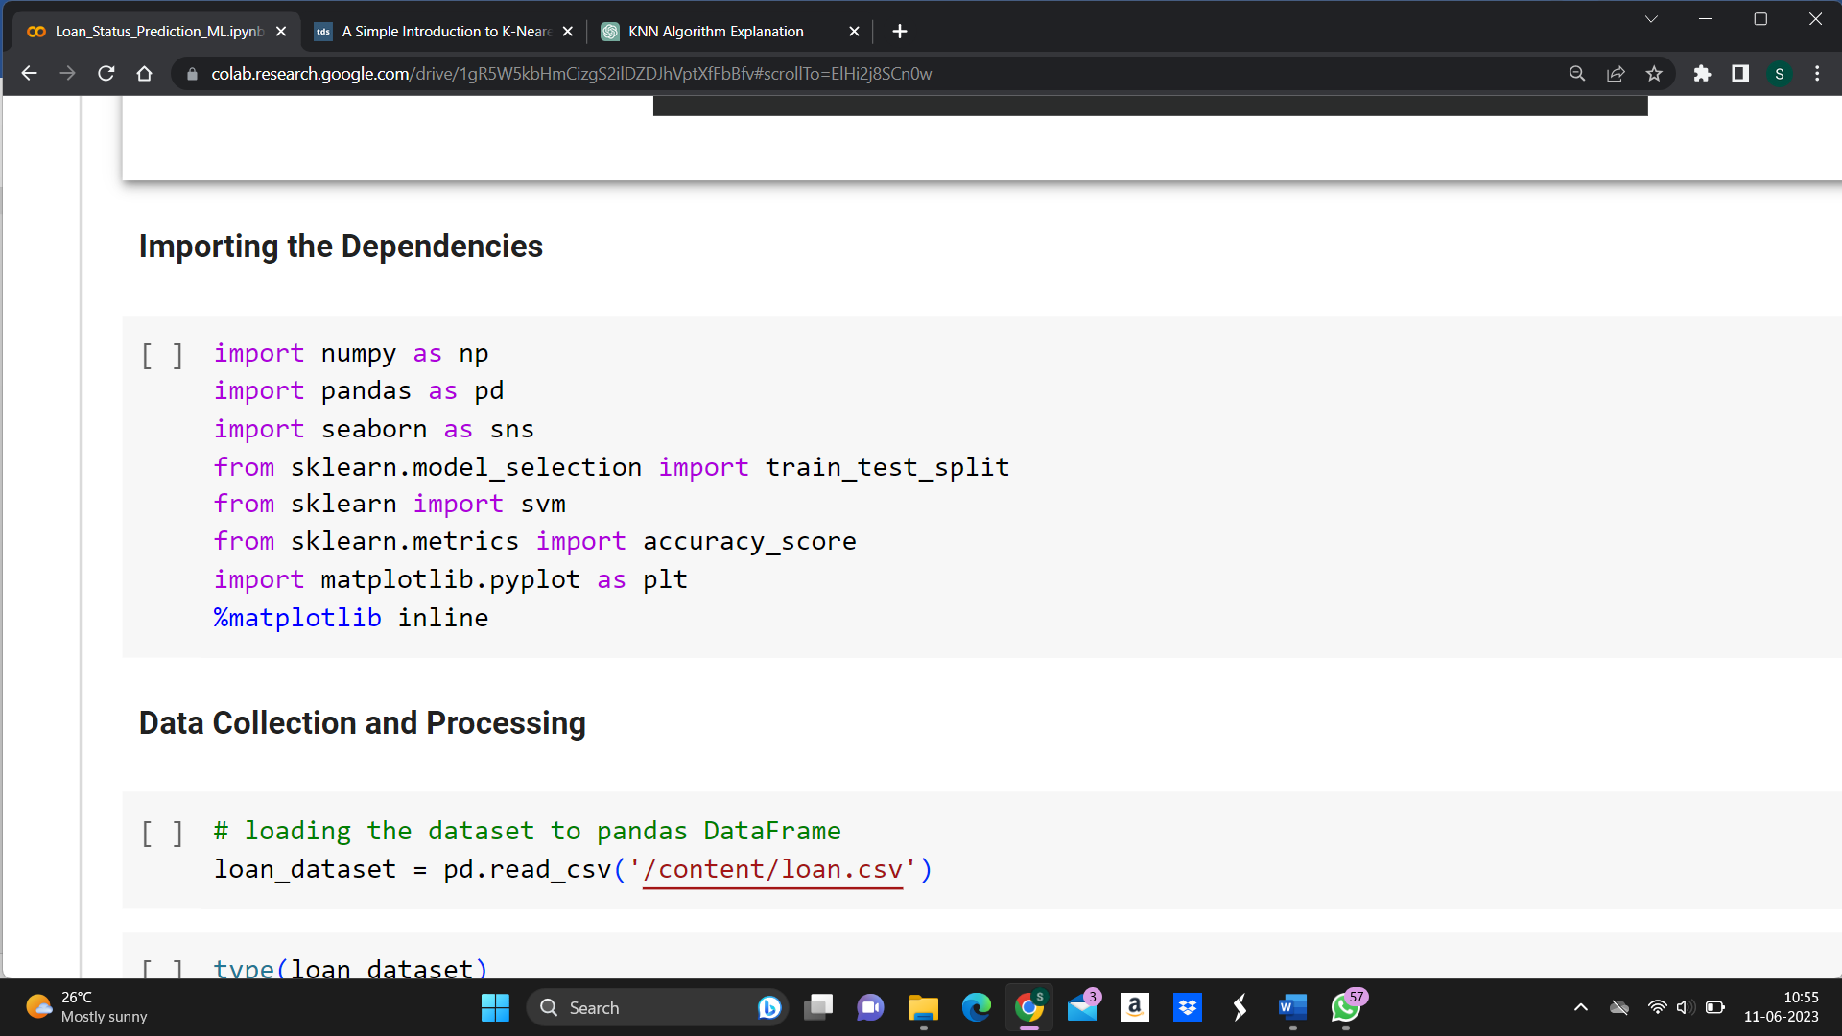

Figure 4.1: Importing packages

Figure 4.1 shows the Importing Packages. When we implement the project, this is first step. Importing packages refers to the process of including external libraries or modules into your programming environment to gain access to their pre-written code and functionality. In most programming languages, including Python, packages provide a way to organize and distribute reusable code.

* **Loading Dataset**

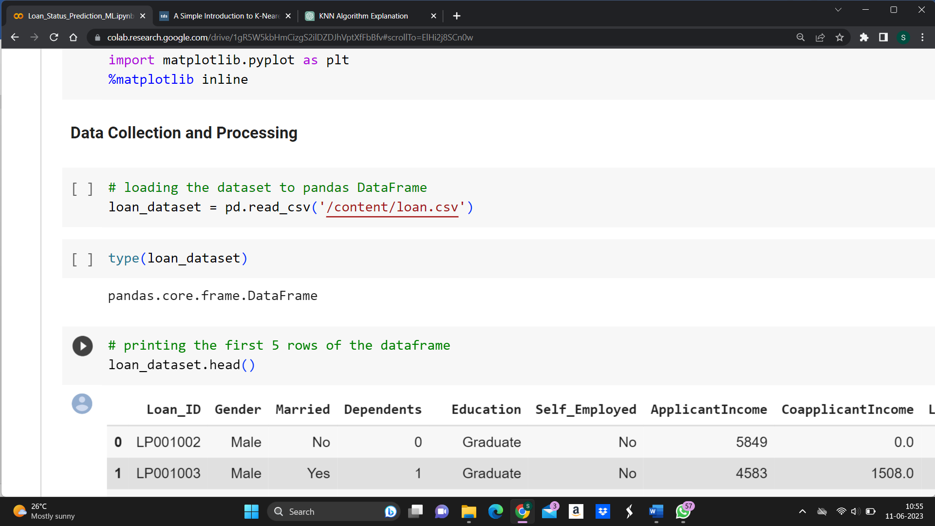

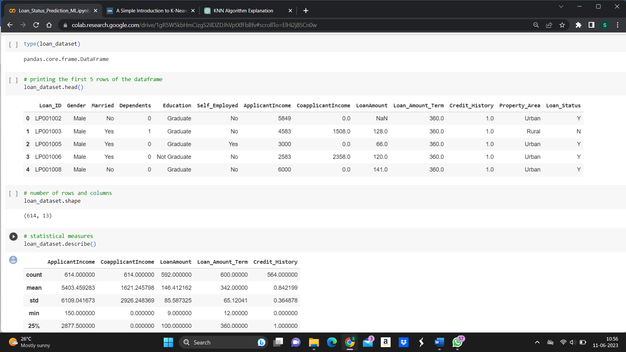

Figure 4.2: Loan Dataset

Figure shows the Dataset. This is the Loan Approval dataset used in this project. The dataset is in the characters and numbers. A dataset refers to a collection of data that is used for training, testing, and evaluating machine learning models. It is a fundamental component of the machine learning workflow and plays a crucial role in training models to make accurate predictions or perform specific tasks.

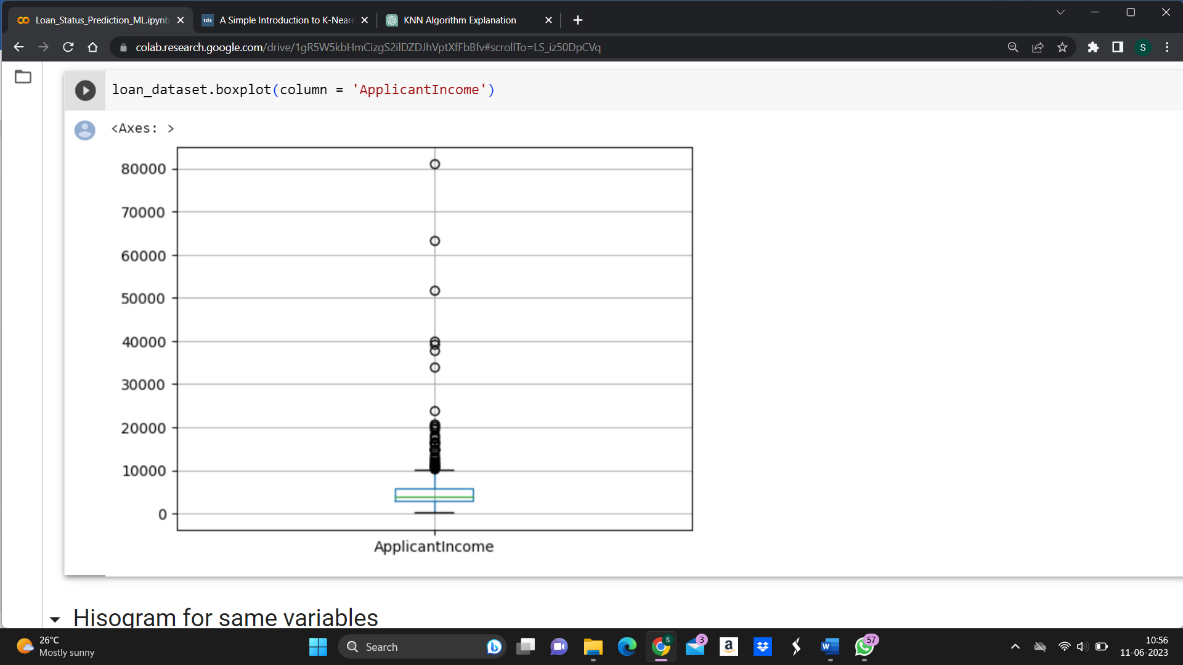

Figure 4.3: Boxplot for applicant income variable

Figure shows the Boxplot for applicant income variable. And it is a graphical representation of the distribution of a numerical variable. It provides a visual summary of key statistics such as the median, quartiles, and potential outliers.

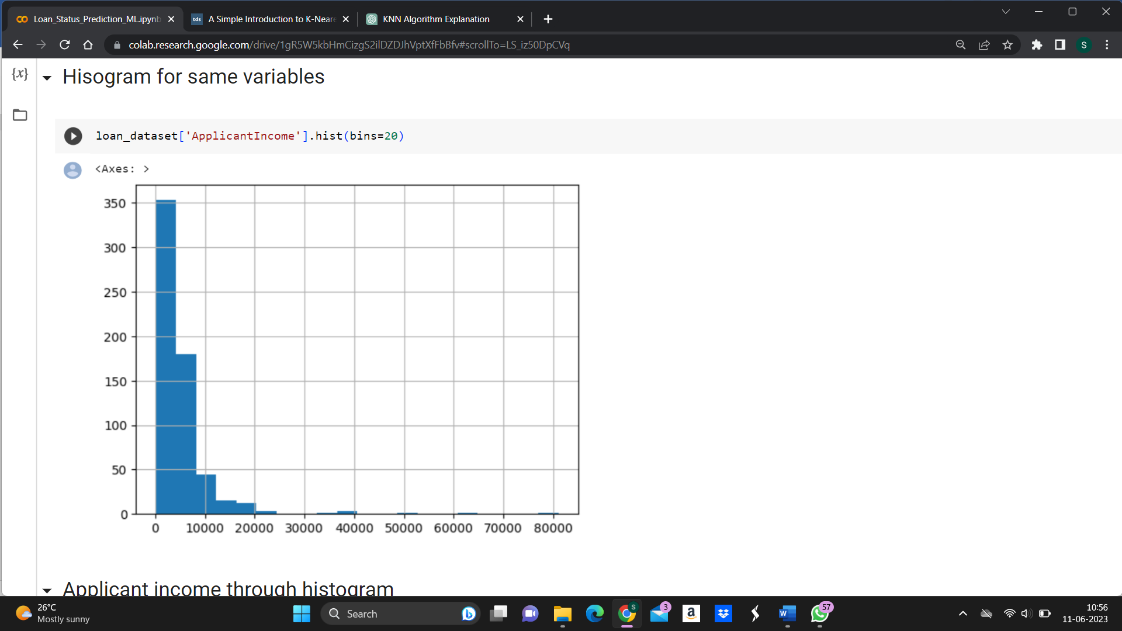

Figure 4.4: Histogram for same variables

Figure shows the Histogram for same variable. A histogram is another graphical representation of the distribution of a numerical variable.

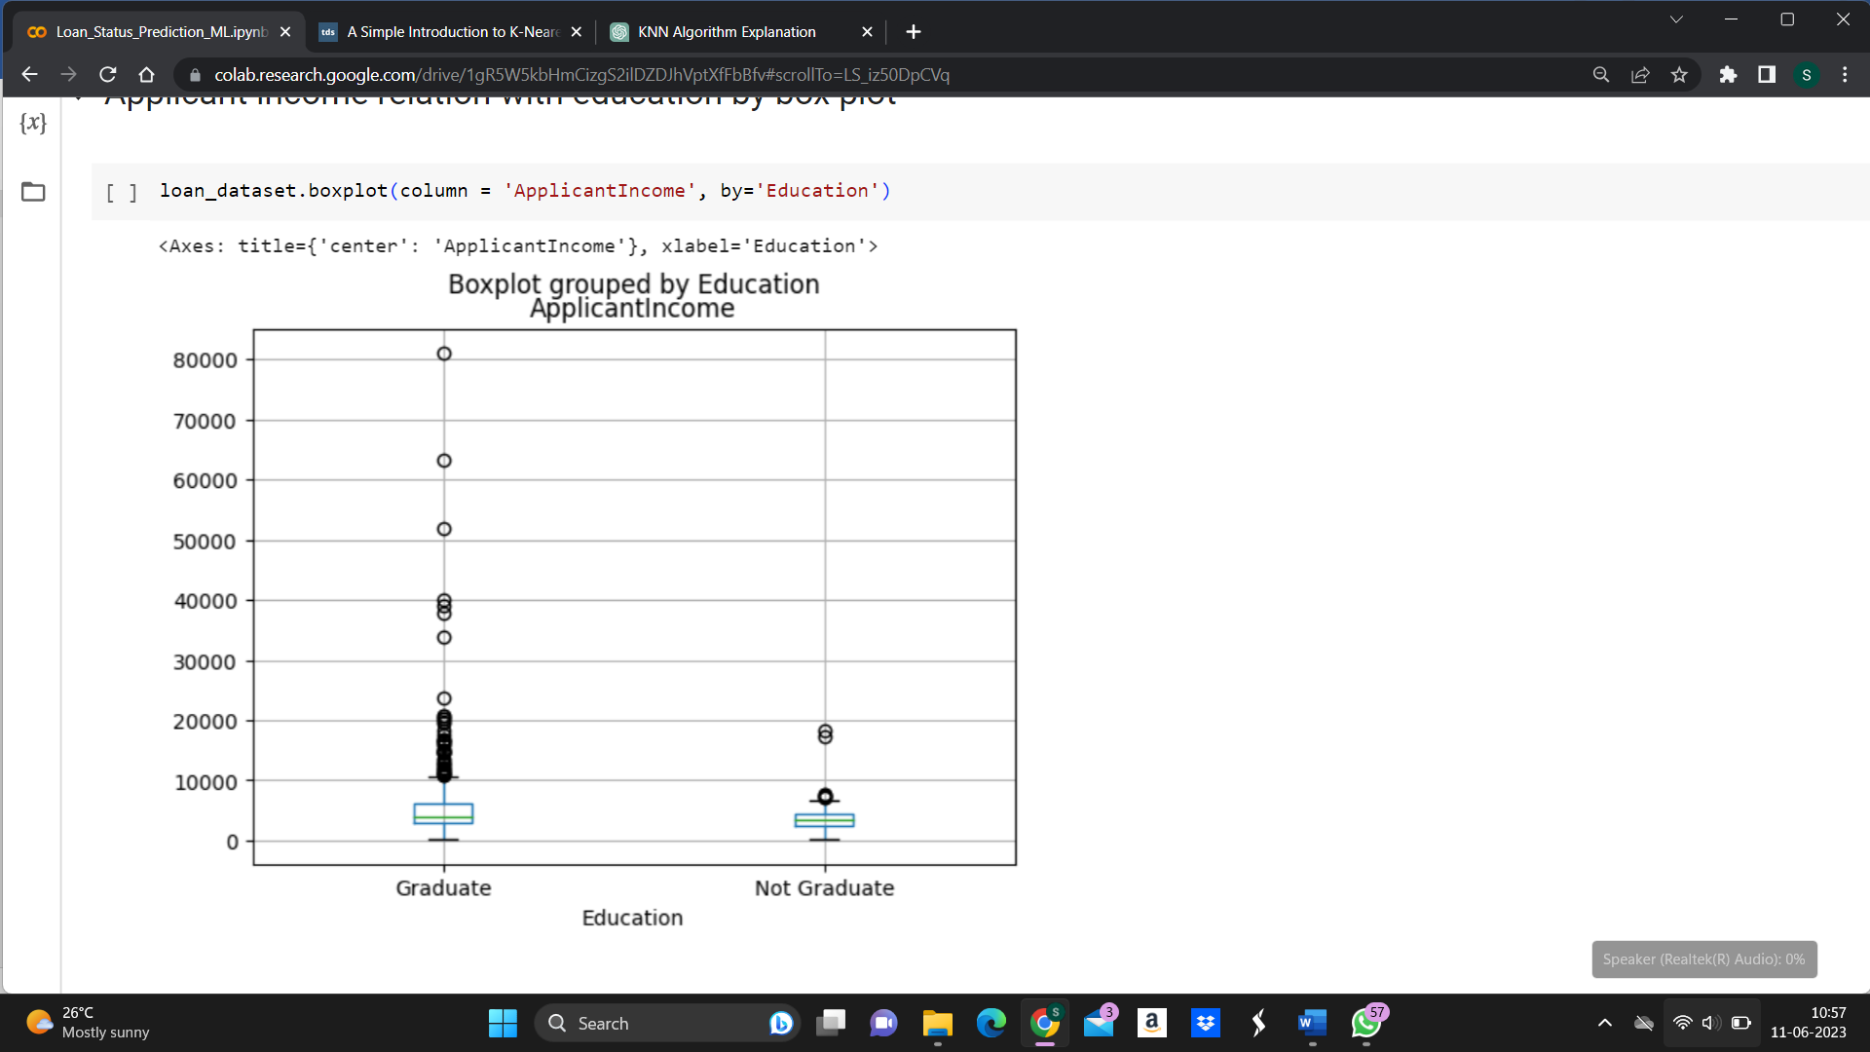

Figure 4.5: Applicant income compare with Education

Figure 4.5 shows the Applicant income relation with education by box plot. Here we explore the relationship between graduate and not graduate using a box plot.

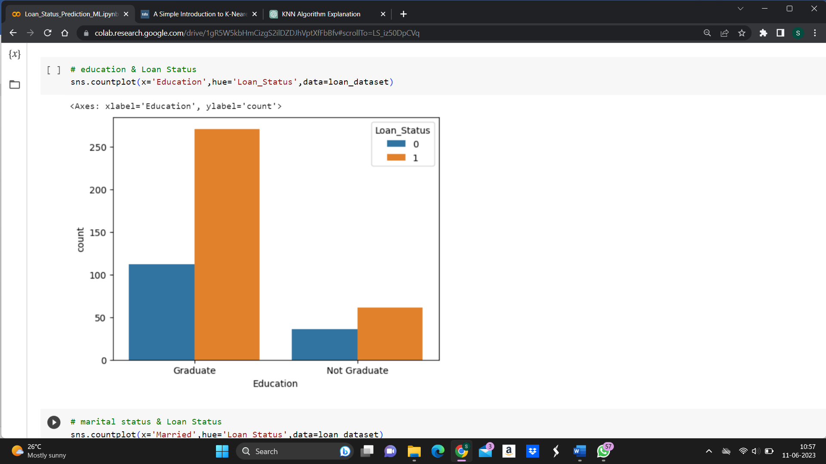

Figure 4.6:  Education Vs Loan Status

Figure 4.6 shows the marital status and loan status. The above code helps to shows the education status and loan status.

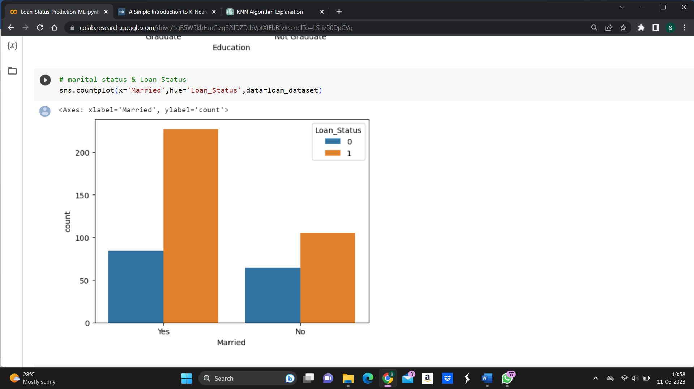

Figure 4.7: Marital status & Loan Status

Figure 4.7 shows the marital status & Loan Status. The code explains about marital status and loan status and plot the graph.

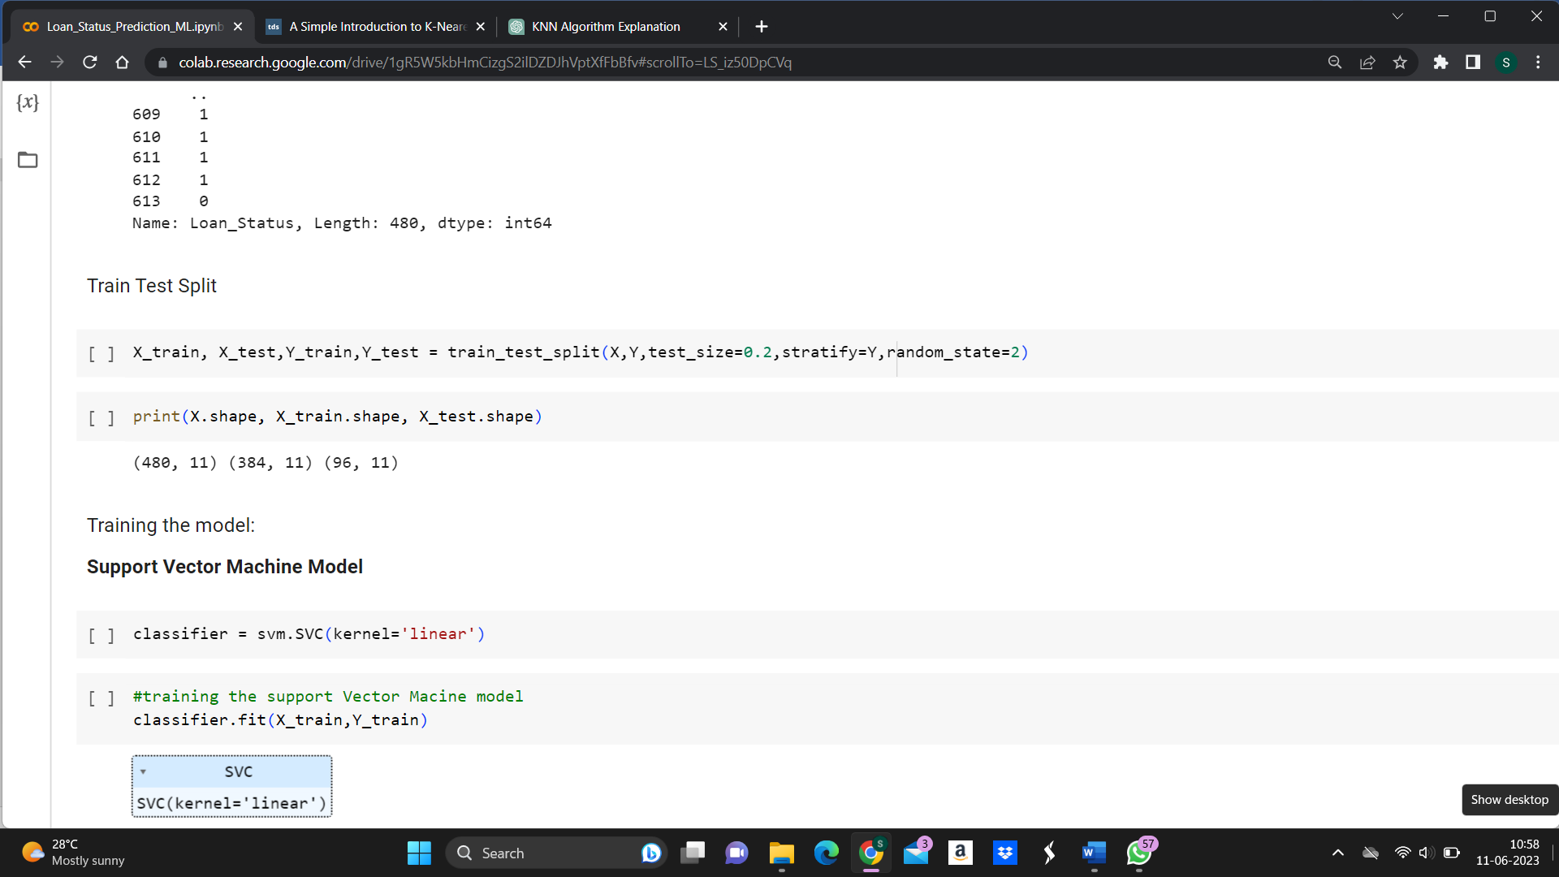

Figure 4.8: Train Test split the data

Figure 4.8 show the Train Test split the data.By performing a train-test split, you have created separate datasets that will be used for training your machine learning model (X_train and y_train) and evaluating its performance (X_test and y_test).

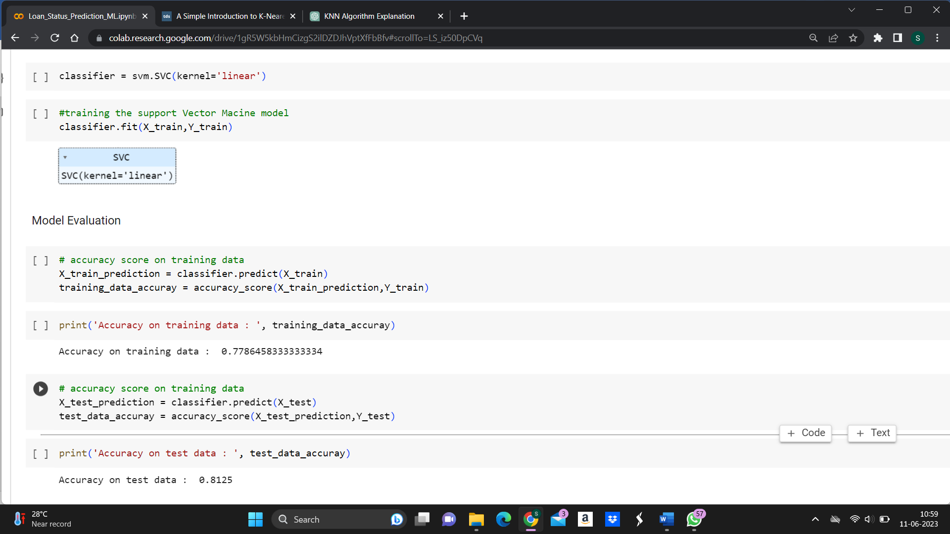

Figure 4.5 Support Vector Machine Model

Figure 4.5 shows to find accuracy using support vector machine model. The above code predict the Training accuracy and testing accuracy using SVM model.

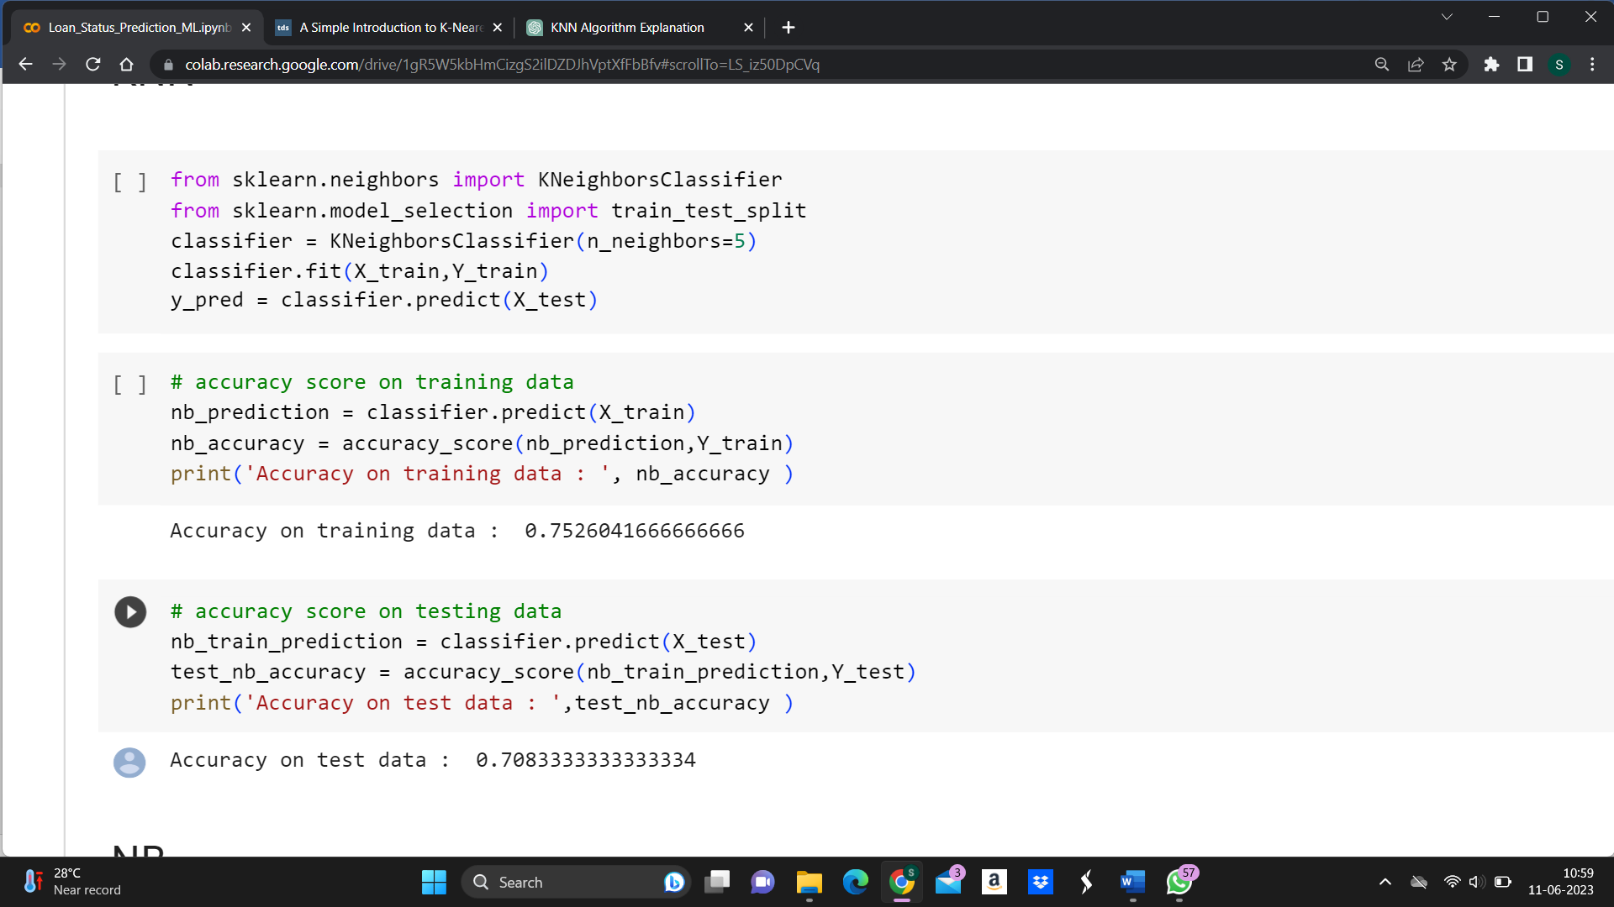

Figure 4.6: KNN

Figure 4.6 shows to find accuracy using support KNN model. The above code predict the Training accuracy and testing accuracy using KNN model.

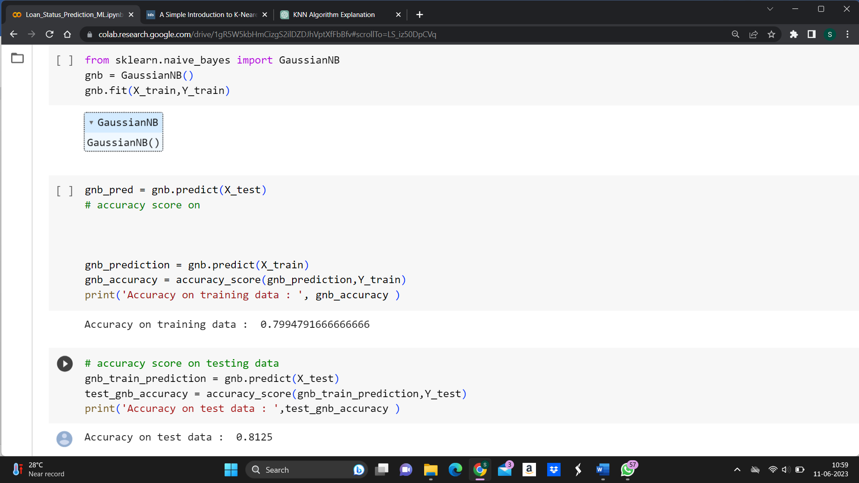

Figure 4.7: Navie Bayes Classifier

Figure 4.7 shows to find accuracy using support Navie Bayes model. The above code predict the Training accuracy and testing accuracy using Navie Bayes model.

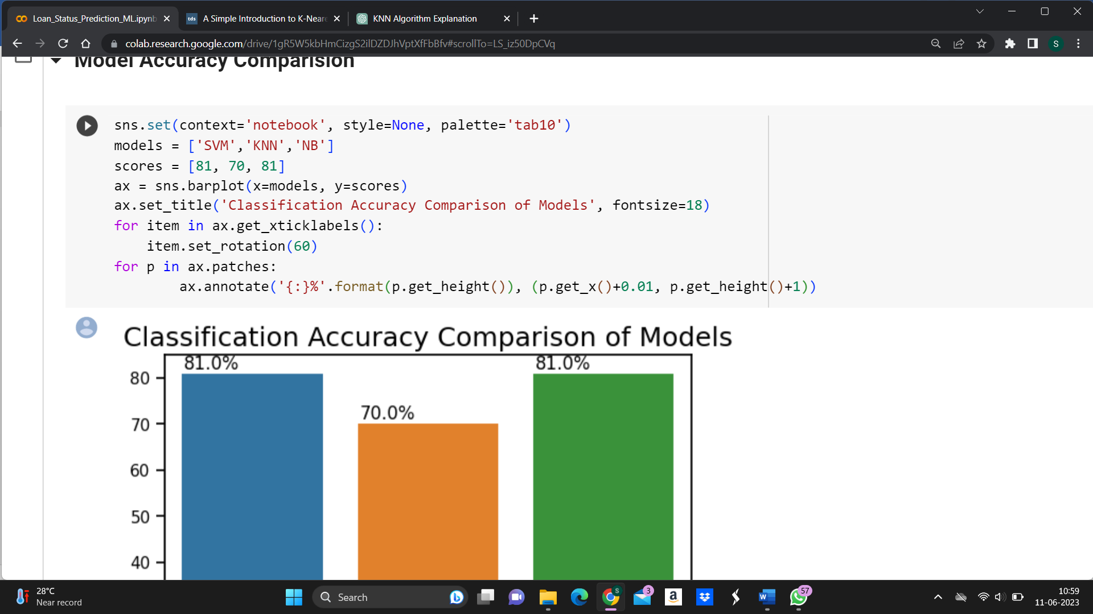

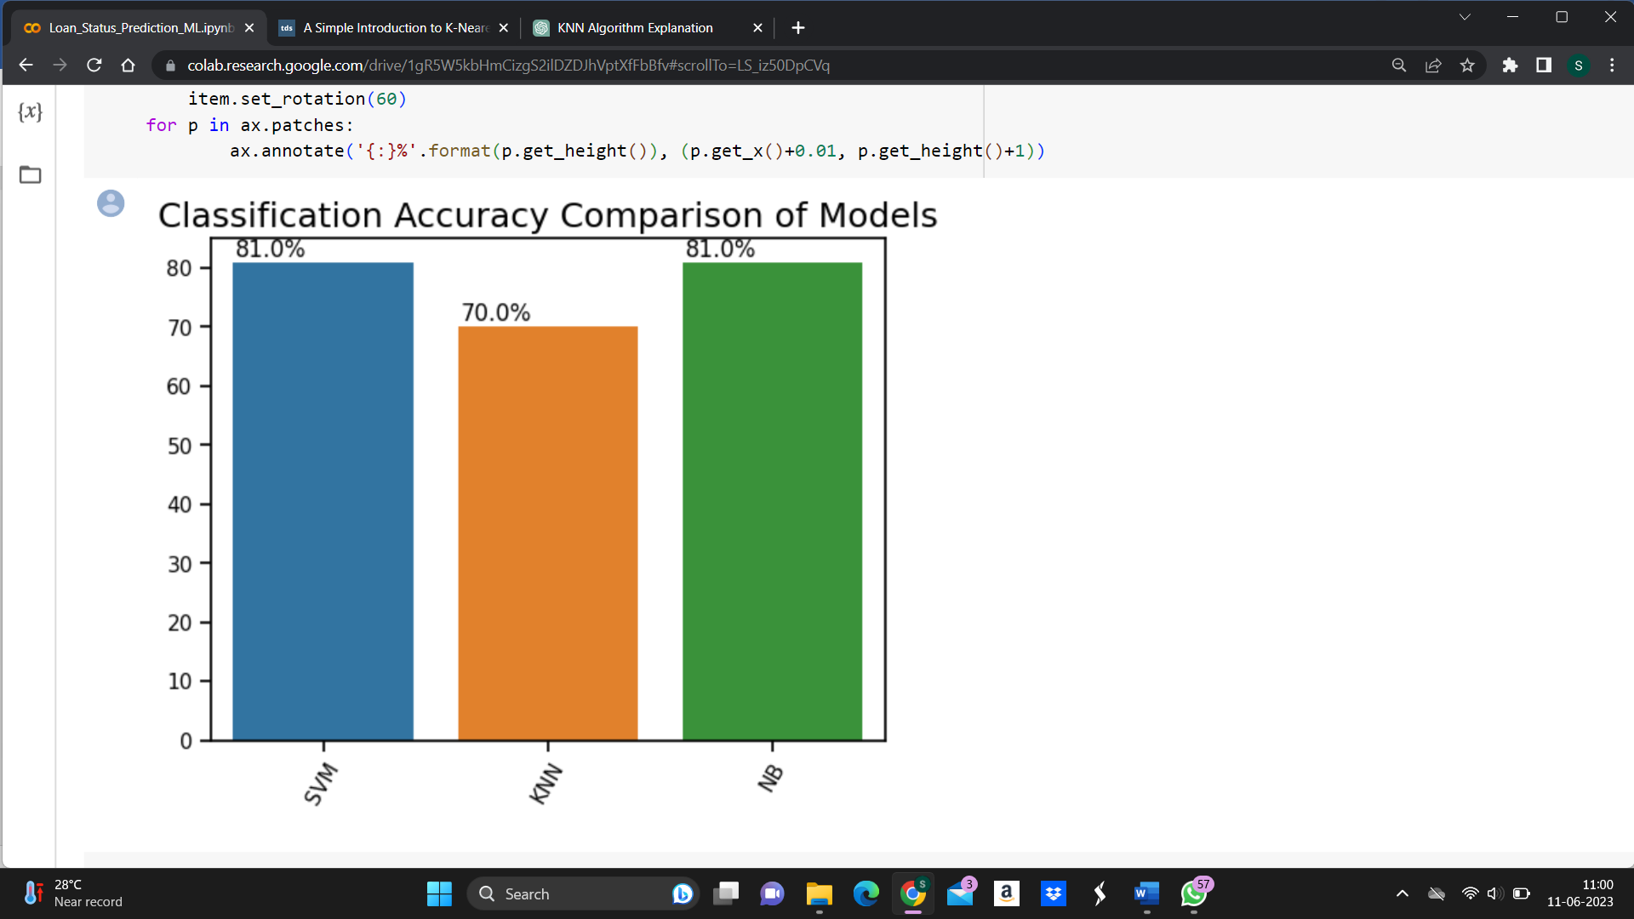

Figure 4.8: Comparison Model

Figure 4.8shows visualize the accuracies of different models. By comparing these models we can easily predict highest accuracy.

**CONCLUSIONS**

From the proper view of analysis this project can be used perfect for detection of clients who are eligible for approval of loan. The application can be used for all banking system. Since the technology is moving towards online, this project has more scope for the upcoming days. Here, we used various machine learning model such as NBC, SVM, KNN & LR. It can be concluded with confidence that the Logistic Regression model is extremely efficient and gives a better result when compared to other models with accuracy of 98%. It works correctly and full fills all requirements of bankers. We created graphical interface to demonstrate the result that predicts the loan is approved or reject to loan applicant or customer very accurately.

**Future Enhancements**

* **Feature Engineering:** Explore additional data sources and variables that could enhance the predictive power of the model. For example, you could include social media data, transaction history, or alternative credit data to capture a more comprehensive picture of the applicant's financial behavior.
* **Advanced Modelling Techniques:** Consider using more sophisticated machine learning algorithms or ensemble methods to improve the accuracy of loan approval predictions. Techniques such as gradient boosting, random forests, or deep learning models may yield better results by capturing complex relationships within the data.
* **Incorporate Explain ability:** Develop methods to interpret and explain the loan approval predictions. This could involve using techniques like feature importance analysis, partial dependence plots, or model-agnostic interpretability methods to provide transparency and increase stakeholders' trust in the model.
* **Real-Time Decision Making:** Implement a system that allows for real-time loan approval decisions based on incoming data. This could involve integrating the loan approval model into an automated decision-making system, enabling quick and efficient loan application processing.
* **Model Monitoring and Updates:** Establish a mechanism to continuously monitor the loan approval model's performance and update it as new data becomes available. Regular model evaluations, validation, and recalibration can help maintain accuracy and ensure the model stays relevant over time.